**10.7 PLANNING PROPOSAL (PP018) TO REZONE THE FORMER FORESTRY SITE - 72-74 MAITLAND STREET, MUSWELLBROOK**

**Attachments:** **a. Pacific Brook Christian School - Rezoning Request - Under Separate Cover**

**Responsible Officer:** **Derek Finnigan - Deputy General Manager**

**Author:** **Sharon Pope - Executive Manager - Environment and Planning**

***Community Plan Issue: Diversify the economy, facilitate the development of intensive agricultur and other growth industries, make the Shire a more attractive place to invest and do business***

***Community Plan Goal: Review the Local Environmental Plan and Development Control Plan to improve investment certainty for industry.***

***Community Plan Strategy: Progress completion of an LEP and DCP.***

**Purpose**

The purpose of the summary section is to provide a brief summary on the reason for preparing the council report. Should be limited to one paragraph.

Council has received a request to amend the Muswellbrook Local Environmental (MLEP) 2009 in relation to 72-74 Maitland Street, Muswellbrook (Lot 100, DP 1261496). The request seeks to allow the construction of an ‘educational establishment’ or residential development as a secondary option.

Council is the Planning Proposal Authority for amendments to the MLEP 2009. The purpose of this report is to seek Council’s endorsement for the preparation of a Planning Proposal to amend the MLEP 2009.

The Planning Proposal aims to rezone Lot 100, DP 1261496, from *RU3 Forestry* zone to R1 “General Residential” zone.

**Officer’s Recommendation**

**Council RESOLVES to:**

1. **Prepare a draft planning proposal, pursuant to Section 3.33 of the *Environmental Planning and Assessment Act 1979,* for an amendment to the *Muswellbrook* *Local Environmental Plan 2009* (MLEP 2009) to:**
2. **amend the zoning of the land from RU3 Forestry to R1 General Residential;**
3. **introduce a Minimum Lot Size (MLS) for the site;**
4. **introduce a Floor Space Ratio (FSR) for the site; and**
5. **introduce a maximum building height for the site.**
6. **Forward the draft planning proposal to the *Department of Planning, Industry and Environment* requesting a Gateway Determination, and exhibit the proposal in accordance with that determination, pursuant to Sections 3.34-3.35 of the *Environmental Planning and Assessment Act 1979*; and**
7. **Request that the Director General of the *Department of Planning, Industry and Environment* issue a Written Authorisation to Council to Exercise Delegation of the plan making functions under Section 3.36 of the *Environmental Planning and Assessment Act 1979* in respect of the planning proposal.**

**Moved: _____________________________ Seconded: _______________________________**

|  |  |  |  |  |  |
| --- | --- | --- | --- | --- | --- |
|  | Cr J. Ledlin |  | Cr G. McNeill |  | Cr R. Scholes |
|  |  |  |  |  |  |
|  | Cr J. Foy |  | Cr M. Bowditch |  | Cr S. Ward |
|  |  |  |  |  |  |
|  | Cr S. Reynolds |  | Cr J.F. Eades |  | Cr B.N. Woodruff |

**BACKGROUND**

The Background section provides the history of the issue.

The subject land is Lot 100, DP 1261496 (72-74 Maitland Street, Muswellbrook). The land is currently zoned *RU3 Forestry* under the MLEP 2009. The property comprises several empty buildings used in association with the former land use, this being a plant nursery. The site is currently vacant, however the proponent intends to establish an ‘educational establishment’ or residential development on the property.

In order to facilitate a future development application for an ‘educational establishment’ or residential development the MLEP 2009 would need to be amended. The preparation of a Planning Proposal is the first step in the process of amending a Local Environmental Plan. Council has received a request to amend the MLEP 2009 to allow the erection of a school as the proponent’s first option (see Attachment A). The Proponent has commenced the State Significant Development process for a school with the Department of Planning, Industry and Environment.

Should the decision to develop a school not proceed, residential development is the alternative for the property.

Council Officers had discussions, initially with prospective purchasers, and then with the successful buyer about the need for a zone change to reflect the fact the site is no longer used for forestry related purposes. Staff indicated that the preferred zone would be *R1 General Residential* to match the zoning of adjoining land and to avoid further commercial development (“ribbon development”) along the Highway.

A planning proposal must be written in accordance with the Department of Planning’s ‘*A Guide to preparing Local Environmental Plans’* and *‘A Guide to preparing Planning Proposals’* as a requirement for the preparation of the gateway determination by the *Department, Planning, Industry and Environment*.

**CONSULTATION**

The Consultation section provides Councillors with a listing of who has been consulted when writing the report. This could cover internal or external parties and/or both.

The planning proposal is the first step in the ‘gateway’ plan-making process and explains the effect of and justification for the initiative. A Gateway Determination will identify if further studies are required and any specific requirements for public exhibition.

Should the Gateway Determination allow public exhibition of the Planning Proposal without further studies, it is anticipated that the proposal would be exhibited during early September 2021.

**REPORT**

The Director/Officer should provide Councillors with as much information as possible on the issue being debated, in order to make an informed decision on the matter.

1. **Location of the Planning Proposal**

The subject land is in Maitland Street, Muswellbrook. The subject land is adjoined to the north by the Muswellbrook Golf Course which is zoned *RE2 Private Recreation.* Land to the south is zoned a combination of *R1 General Residential, B2 Local Centre* and *B5 Business Development* land and is occupied by a mixture of residential and commercial development.

The site is adjacent to Maitland Street (New England Highway), which provides for traffic movements north west toward the Muswellbrook Central Business District (CBD), and south to the Muswellbrook Showground and TAFE. An aerial map and land zoning map are provided in Figures 1 & 2.

The subject land is identified as vacant land and compromises several empty buildings used in association with the former land use (plant nursery).

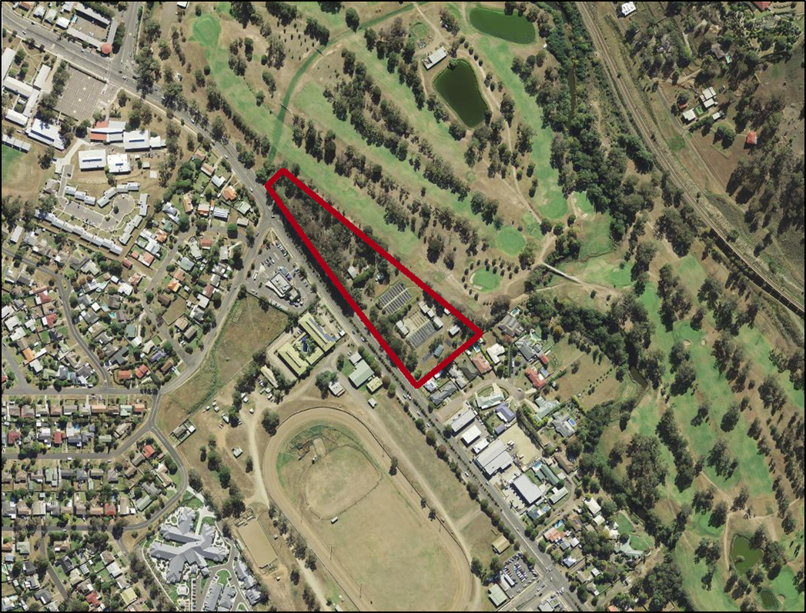

**Figure 1: Location of the Subject Land identified as Lot 100, DP 1261496, 72-74 Maitland Street, Muswellbrook**

|  |  |
| --- | --- |
|  |  |

**Figure 2: Current Zoning of the Subject Land**

1. **MLEP 2009 Amendments**

The objectives of the Planning Proposal for Lot 100, DP 1261496, 72-74 Maitland Street, Muswellbrook is to:

1. Rezone the subject land from *RU3 Forestry* zone to *R1 General Residential* zone;
2. Introduce a Minimum Lot Size (MLS) of 600 m² to the proposed residential land;
3. Introduce a Floor Space Ratio (FSR) of 0.5:1 to the proposed residential land; and
4. Introduce a Maximum Building Height (MBH) of 8.5 m to the proposed residential land.

The location is adjacent to land zoned R1 - General Residential, B2 - Local Centre and RE2 - Private Recreation, and is situated close to the town centre of Muswellbrook.

Any future development application for the subject land will need to consider the likely potential impacts of, but not be limited to, additional traffic, site manoeuvrability and infrastructure provision associated with the development. As the proposed zoning is appropriate for the area it is therefore recommended Council support the proposal.

1. **Consideration of Planning Proposal in Relation to Applicable Local and Regional Plans and Strategies**

The Planning Proposal is consistent with the aims and objectives of the applicable local and regional plans and strategies. Below is a brief outline of the planning proposal’s consistency with the applicable local and regional plans and strategies.

*Muswellbrook Local Strategic Plan 2020 – 2040 (LSPS)*

The LSPS implements the actions in the Hunter Regional Plan and Council’s own priorities as set out in the Muswellbrook Community Strategic Plan and other adopted strategies and actions. Improving education and training opportunities in the community is identified in the LSPS as desirable to improve liveability of the Shire.

*Hunter Regional Plan 2036*

Direction 23 of the *Hunter Regional Plan 2036* identifies growing centres and renewing corridors. Action 23.1 *“Concentrate growth in strategic centres, local centres and urban renewal corridors to support economic and population growth and a mix of uses.’,* is one focus of the proposed rezoning*.* The Planning Proposal is consistent with both the action and direction of the *Hunter Regional Plan 2036* as it will contribute to urban revitalisation for Muswellbrook by providing a new school facility. Furthermore, the proposed development will improve the streetscape and assist in supporting economic growth.

This Proposal is also consistent with Direction 13, and in particular “*Action 13.3 Amend planning controls to deliver greater certainty of land use.”* The current Forestry zoning is not appropriate for the site; changing the zoning would be consistent with this direction.

*Muswellbrook Land Use Development Strategy*

The *Land Use Development Strategy* sets out the future direction for land use in the Muswellbrook local government area for the next 20 years and establishes an overarching policy framework focused on the best use of land for the best community value. The proposal is consistent with the strategy as it provides opportunities for urban growth and encourages urban renewal in an area close to the Central Business District of Muswellbrook. The Strategy also focuses on encouraging the establishment of regional education and related facilities within the Muswellbrook town centre. The Planning Proposal achieves this through the development of the multifunctional school.

*Muswellbrook Community Strategic Plan 2013-2023*

The *Muswellbrook Community Strategic Plan 2013-2023* identifies community services and infrastructure to support the community as being important drivers of Muswellbrook Shire’s future. The plan also identifies supporting the development of the Education and Training Industry as a method of achieving this growth. The Planning Proposal is consistent with this aim of the *Muswellbrook Community Strategic Plan 2013-2023* as the proposal gives effect to the Plan. That is, it will facilitate an ‘educational establishment’ (Junior, Middle and Senior School), as the preferred development, close to the Muswellbrook CBD.

**OPTIONS**

The purpose of the Options Section is to provide Councillors with viable alternatives to the recommendation. This can be useful where there are two or three viable options to consider.

Council may:

1. Resolve to prepare a Planning Proposal to amend MLEP 2009 to permit an educational establishment or residential development on Lot 100, DP 1261496. This is the preferred option as the current zone is an anomaly and no development can currently occur on the site due to that zone; or
2. Reject the Amendment request and take no further action.

Where Council does not support a request to prepare a planning proposal, Council is required to notify the Proponent as soon as practicable in writing that the proposal is not supported. The Proponent may seek a review of the decisions by DPIE.

**CONCLUSION**

Council Officers had discussions, initially with prospective purchasers, and then with the successful buyer about the need for a zone change for this site to reflect the fact the site is no longer used for forestry related purposes. Staff indicated that the preferred zone would be R1 General Residential to match the zoning of adjoining land.

The site is located adjacent to land zoned R1 - General Residential, B2 - Local Centre and RE2 - Private Recreation and is situated close to the town centre of Muswellbrook. The Proponent has now formally requested that Council rezone the site.

It is recommended that Council amend Muswellbrook Local Environmental Plan 2009 (MLEP 2009) to:

i) change the zoning of the land to R1 General Residential;

ii) introduce a Minimum Lot Size (MLS) for the site;

iii) introduce a Floor Space Ratio (FSR) for the site; and

iv) introduce a maximum building height for the site

**SOCIAL IMPLICATIONS**

The Planning Proposal will facilitate expansion of educational establishments (Junior, Middle and Senior School) in Muswellbrook.

**FINANCIAL IMPLICATIONS**

This section details any financial issues that need to be considered. The Director/Officer should provide Councillors with detail as to where any funding is to come from and whether the required funding is already in the Operational Plan or is required to be sourced from a service already being provided.

The applicant has paid application fees in accordance with Council’s 2019/2020 fees and charges.

**STATUTORY IMPLICATIONS**

This section details any statutory implications under the Local Government Act 1993 with this matter.

The Planning Proposal seeks to make an amendment to the MLEP 2009. The requested amendment is an Administrative Amendment involving a change to the zoning and a number of map layers applying to the lot.

**LEGAL IMPLICATIONS**

This Director/Officer should discuss any legal issues in this section. This could relate to sections of Acts or Regulations and/or legal cases. The Officer is required to detail any legal implications to the Councillors.

In order to amend the MLEP 2009, Council is required to submit the planning proposal to the Department of Planning, Industry and Environment for a Gateway Determination. The proposal has been written in accordance with the Department of Planning, Industry and Environment’s ‘A Guide to preparing Local Environmental Plans’ and ‘A Guide to preparing Planning Proposals’. Council will also request the Minister for Planning, Industry and Environment to exercise their planning powers under Section 3.22 of the Environmental Planning and Assessment Act 1979 and grant Council delegated authority to amend the MLEP 2009.

**RISK MANAGEMENT IMPLICATIONS**

This section to be used to identify any risks associated with the item to be considered.

By following guidelines issued by DPIE any risks to Council in rezoning the site will be minimised.